Case: Bottle Cap 7

Date: 04/12/2017

Team Member Names (list below)
Dayron
Johnson
Yezehao Huai
Li Mo

A. Understanding the Case.
A.1. Create a flow chart and paste it here.

B. Control Charts – Overall

B.1. Explain why you would want to monitor the process with control charts and how you will analyze charts once they are run. What conditions will you be looking for and what can you conclude from analyzing charts? (This is general discussion. Do not include your evaluation of the charts here.)
We want to see if a process is stable and to identify special causes as they occur. Except with a control chart, we are monitoring the process with sample statistics rather than individual observations. By using sample statistics, we can actually identify the potential special causes more quickly. A control chart is a line graph which displays characteristics of a processes behavior over time. We can monitor the location of the data using a central tendency measure. This is usually the mean, although I have seen charts using the median. We also want to monitor the dispersion. We will do this using the range or standard deviation. There are charts for both continuous data and discrete data. The main question the charts are answering is “Is the process in statistical control?” If the chart indicates it is not in statistical control, action needs to be taken.

B.2. Paste the overall control chart here.

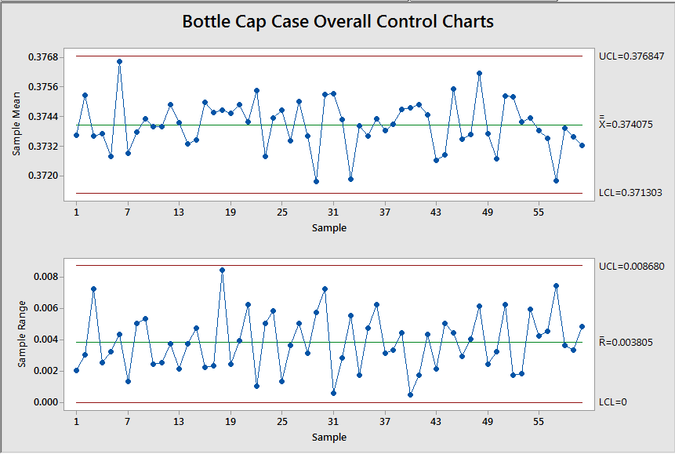

B.3. Analyze the overall control chart, describing your findings and conclusions.
The process could be consider stable.

B.3. Explain the purpose of a capability analysis. Include assumptions required for use and explanations of Cp, Cpl, Cpu, and Cpk.
The capability is the 6σ range inherent process variation.
A specification will generally have
– Upper specification limit (USL)
– Nominal or target value
– Lower specification limit (LSL).
Where the USL-LSL is greater than 6σ, Cp is greater than 1. If the process is centered, and Cp > 1, then a low number of nonconforming items will be produced.
Cpu and Cpl takes μ and the upper and lower specifications into account.
A process capability ratio that does take into account centering is Cpk defined as Cpk = min (Cpu, Cpl)
Cpk must be greater than 1 for a process to be considered capable.

B.4. Paste the overall capability analysis here.
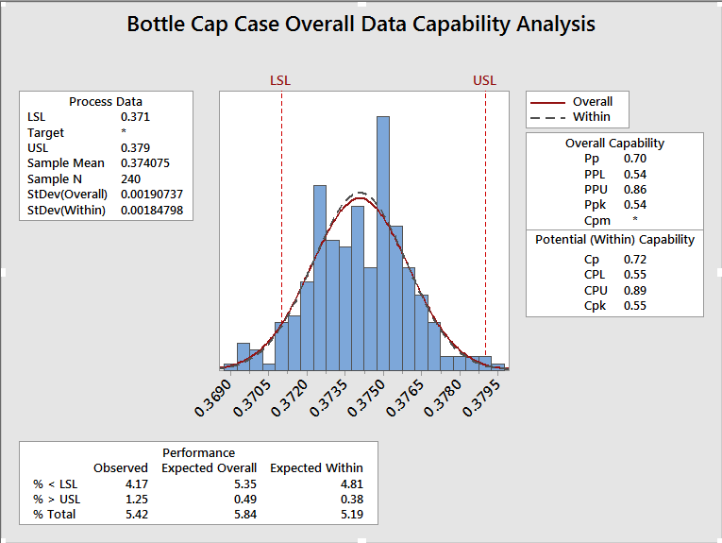
B.5. Based on the results of the overall capability analysis, what is the capability of the current process to hold the diameter? (discuss Cp, Cpu, Cpl and Cpk and describe what each tells about the process). Indicate the % out of specification and describe how this percentage relates to the indices.
For overall, Cp=0.70 Cpu=0.86 Cpl=0.54 Cpk=0.55, it is not capable.
Z.LSL= -1.57 Z.USL= 2.62
Total% out of specification:0.0582+0.9956=1.0538%
Parts per million nonconforming =10538ppm

C. Control charts – individual shifts.
C.1. Paste the three shifts’ Sixpack reports here.

C.2. Analyze and compare the three shifts’ control charts. Describe your findings and conclusions.

C.3. Analyze and compare the three shifts’ capability analysis. Describe your findings and conclusions.

D Temperature versus Diameter
D. 1 Paste the scatter diagram of temperature versus diameter here.

D.2. Describe your conclusions in analyzing the scatter diagram. Discuss how can you use this information?

E Gage R&R
E.1. Paste the session window and the “Report for Measurement” output from the Gage R&R here.

E.2. Explain what the repeatability and reproducibility data from the study indicate. Explain any

E.3. Is the %GRR measurement system acceptable per the MSA Guidelines? Explain.

E.4. What does the % study variance to tolerance tell you?

F. Causes of variation
F.1. Paste your causes of variation diagram here.

F.2. Based on the analysis so far, what are the primary causes of variation in the process? Explain.

G. Short term process recommendations
G. Based on the analysis thus far (all parts), what recommendations do you have for the process? Make at least three specific recommendations. State the recommendation, and then give the reason for the recommendation citing the data from the analysis. (Each recommendation in its own paragraph.)

H. Capability after improvements
H.1. Paste “after” control charts here.

H.2. Analyze the control charts and describe your findings and conclusions.

H.3. Paste “after” capability analysis here.

H.4. Analyze the Capability Analysis and describe your findings and conclusions.

I. Statistical Significance of Changes
I.1. At a 95% level of confidence, can you conclude there has been a reduction in the variance before (all operators) and after (improved data). Comment on the strength of the conclusion. Paste in Minitab output and discuss.

I.2. At a 95% level of confidence, what conclusion can you draw about the process mean before (all operators) and after (improved data). Paste in Minitab output and discuss.

J. Long Term Recommendations
J.1. Provide a specific recommendation relative to further reducing variation in the process. State the recommendation and refer to previous aspects of the case/analysis in giving reasons for the recommendation.)

J.2. Provide a specific recommendation for continued monitoring of the injection molding process. Describe the steps needed to implement the recommendation.

